Dear BBPOA Members,

It is with great sadness that we announce the passing of Margaret Johnson, longtime Bethune resident and founding member and past President of Bethune Beach Property Owners Association.  She was loved by many.

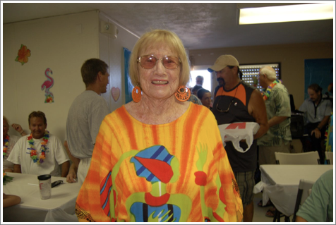

                        Margaret Johnson - Photo courtesy of Jan Young

Margaret was instrumental in directing how this community developed.  She worked diligently to get the roads paved and creatively named the streets.  She fought to get septic tanks replaced with sewers and was a founding member of the current Association working diligently with Volusia County to improve our part of the world.

Margaret was a shining beacon to this community and knew how to get things done.  She never shied away from a challenge and was a neighbor to all.

An obituary will be printed with more details, but the information available thus far is that services will be held on Saturday, January 26 at Settle Wilder funeral home located at 406 S Orange St. NSB, FL 32168.  The viewing will begin at 12:00 p.m. and the funeral at 1:00 p.m.